**Design Thinking Project Workbook**

**Don't find customers for your product but find products for your customers**

**1. Team**

**Team Name:**

**Content management System**

**Team Members:**

1. [Jayakanth, Lead & backend, 2320090050@klh.edu.in]
2. [Saketh, Front End, 2320030440@klh.edu.in]
3. [Anubhav, Backend, 2320030416@klh.edu.in]
4. [Jagadesh, Tester, 2320090054@klh.edu.in]
5. [Sanjay, SQL, 2320030253@klh.edu.in]

**2. Problem/Opportunity Domain**

**Domain of Interest: Content Management Systems (CMS) for digital content creation, organization, and publication.**

**Description of the Domain: The CMS domain is critical in enabling individuals, businesses, and organizations to create, manage, and distribute digital content without extensive technical skills. Key elements of this domain include content creation, storage, retrieval, and workflow management. CMS solutions face challenges like scalability, security, content organization, and the integration of various multimedia types. With increasing digital transformation, there is an opportunity to create CMS platforms that are more user-friendly, flexible, and secure, especially for businesses aiming for high content production and engagement.**

**Why did you choose this domain?: This domain was chosen due to the high demand for CMS platforms as businesses and individuals continue to expand their digital presence. A Java-based CMS allows leveraging Java's robust ecosystem, making it a strategic choice for developing scalable and reliable systems. Additionally, CMS solutions are essential across various industries, ensuring strong market potential and the ability to address a wide range of content-related challenges.**

**3. Problem/Opportunity Statement**

**Problem Statement: Many organizations struggle with effectively managing, organizing, and publishing content due to limitations in existing content management systems. These limitations affect productivity, increase operational costs, and reduce engagement with their target audiences.**

**Problem Description: The challenge lies in providing a user-friendly, scalable, and secure content management solution that allows teams to easily create, organize, and publish content without technical bottlenecks. Existing CMS platforms can be complex, difficult to integrate with other tools, and lack sufficient customization options to meet diverse organizational needs.**

**Context (When does the problem occur): This problem typically arises when organizations grow their content output, diversify their media formats, or expand their digital presence, requiring a scalable and efficient CMS. It is especially prominent in situations where multiple teams collaborate, where extensive security protocols are necessary, or when content needs to be delivered to various platforms.**

**Alternatives (What does the customer do to fix the problem): Organizations may use popular CMS platforms like WordPress or Joomla, hire dedicated developers to customize their CMS, or rely on manual processes for content organization and publishing.**

**Customers (Who has the problem most often): The primary users affected are businesses, educational institutions, media companies, and other organizations that need to regularly create, manage, and publish digital content.**

**Emotional Impact (How does the customer feel): Customers often feel frustrated, overwhelmed, or dissatisfied with existing solutions, especially when they encounter system limitations, customization issues, or security concerns. The complexity of many CMS platforms can lead to stress and frustration, particularly for non-technical users.**

**Quantifiable Impact (What is the measurable impact): The measurable impact includes time wasted on inefficient workflows, increased operational costs for CMS maintenance or customization, and potential revenue loss due to reduced user engagement or downtime.**

**Alternative Shortcomings (What are the disadvantages of the alternatives): Existing solutions may be costly, especially if custom development is required. Popular CMS platforms often have limited flexibility and customization options and may involve high maintenance costs, security vulnerabilities, and a steep learning curve.**

**3. Addressing SDGs**

**Relevant Sustainable Development Goals (SDGs)**

1. **Goal 4: Quality Education – Enhancing access to information and educational content through a well-organized CMS.**
2. **Goal 8: Decent Work and Economic Growth – Enabling businesses to streamline content creation and management, boosting productivity.**
3. **Goal 9: Industry, Innovation, and Infrastructure – Supporting digital infrastructure development by creating efficient tools for content management.**
4. **Goal 12: Responsible Consumption and Production – Facilitating efficient content organization and publication, reducing redundant resources and supporting sustainable digital practices.**

**How does your problem/opportunity address these SDGs?**

**Goal 4: By developing a CMS that supports easy access to organized content, educational institutions can use the system to enhance learning. Organized, accessible information allows students and educators to find relevant materials quickly, enhancing the quality of education.**

**Goal 8: A CMS that simplifies content workflows can make digital work environments more efficient. Businesses can focus on innovation and productivity without getting bogged down by content management issues, supporting economic growth.**

**Goal 9: Developing an adaptable, user-friendly CMS enhances digital infrastructure, fostering innovation. This system can serve as a foundation for future developments, encouraging industry-wide improvements.**

**Goal 12: The CMS project aims to reduce digital waste by organizing content efficiently, eliminating duplicate resources, and fostering responsible consumption of digital assets.**

**4. Stakeholders**

Answer these below questions to understand the stakeholder related to your project

1. **Who are the key stakeholders involved in or affected by this project.**

Content creators, end-users, IT team, leadership, compliance officers, external developers.

1. **What roles do the stakeholders play in the success of the innovation?**

Each contributes to usability, experience, maintenance, resources, standards, and support

1. **What are the main interests and concerns of each stakeholder?**

Focus on usability, navigation, reliability, ROI, security, and integration.

1. **How much influence does each stakeholder have on the outcome of the project?**

**Leadership, IT, and compliance are high; creators and users moderate; developers low-moderate.**

1. **What is the level of engagement or support expected from each stakeholder?**

**High from leadership and IT; moderate from creators and users; as needed from others.**

1. **Are there any conflicts of interest between stakeholders? If so, how can they be addressed?**

**Balance flexibility with security, speed with quality, and customization with simplicity.**

1. **How will you communicate and collaborate with stakeholders throughout the project?**

**Weekly updates, feedback sessions, shared documentation, using real-time channels.**

1. **What potential risks do stakeholders bring to the project, and how can these be mitigated?**

User resistance (training), security (audits), budget (prioritization), compatibility (IT involvement).

**5. Power Interest Matrix of Stakeholders**

**Power Interest Matrix: Provide a diagrammatic representation of Power Interest Matrix**

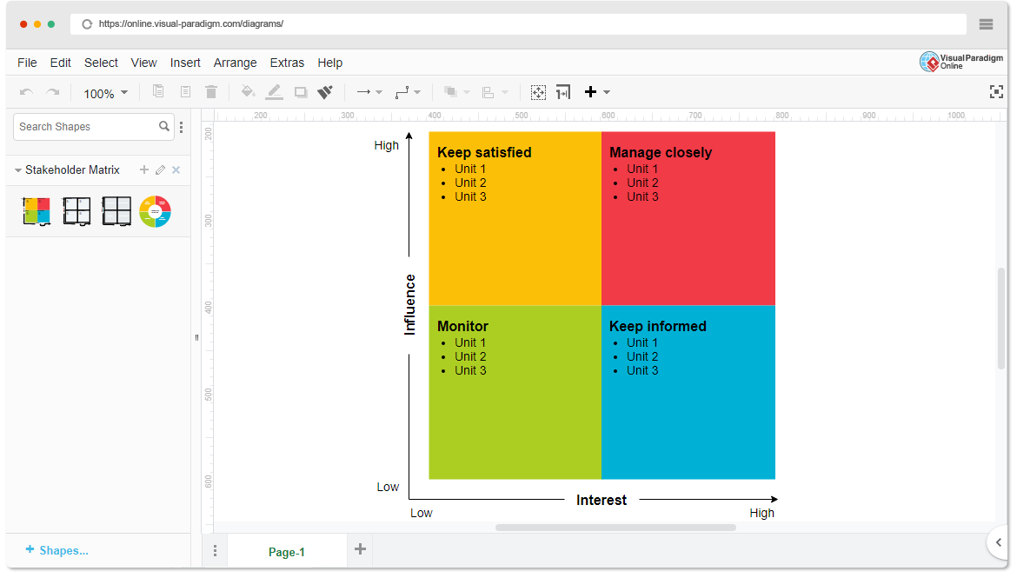

* **High Power, High Interest**: Leadership, IT Team
* **High Power, Low Interest**: Compliance Officers
* **Low Power, High Interest**: Content Creators, End-Users
* **Low Power, Low Interest**: External Developers

1. **Empathetic Interviews**

**Conduct Skilled interview with at least 30 citizens/Users by asking open ended questions (What, why/How etc) and list the insights as per the format below**

| **I Need to Know** | **Questions I Will Ask** | **Insights I Hope to Gain** |
| --- | --- | --- |
|  |  |  |

|  |  |  |
| --- | --- | --- |
| **Thoughts** | What do you think about the current CMS system you use? | Users’ perception of existing CMS functionality. |

|  |  |  |
| --- | --- | --- |
|  | Why do you prefer one CMS over another? | Preferences and reasons behind CMS choices. |

|  |  |  |
| --- | --- | --- |
|  | What features do you believe are missing in your current CMS? | Identifying feature gaps in current CMS options. |

|  |  |  |
| --- | --- | --- |
| **Feelings** | How does using your current CMS make you feel? | Emotional connection or frustration with CMS. |

|  |  |  |
| --- | --- | --- |
|  | What challenges do you face when managing content? | Pain points and emotional impact on users. |

|  |  |  |
| --- | --- | --- |
|  | How confident are you in using the CMS for advanced tasks? | User confidence and comfort level. |

|  |  |  |
| --- | --- | --- |
| **Actions** | How do you typically organize or edit content on your CMS? | Common user practices and workflows. |

|  |  |  |
| --- | --- | --- |
|  | What steps do you take when something doesn’t work as expected? | Troubleshooting habits and resource needs. |

|  |
| --- |
|  |

**SKILLED INTERVIEW REPORT**

**(Examples are given. Erase them and fill with your user information.)**

| **User/Interviewee** | **Questions Asked** | **Insights Gained (NOT THEIR ANSWERS)** |
| --- | --- | --- |

|  |  |  |
| --- | --- | --- |
| **Priya S., Blogger** | What do you think about the current CMS system you use? | Users desire more customization options and simpler navigation. |

|  |  |  |
| --- | --- | --- |
| **Amit K., IT Admin** | How do you feel about managing security in your CMS? | Security features in CMS are critical but sometimes overly complex. |

|  |  |  |
| --- | --- | --- |
| **Sara L., Marketing** | How do you typically organize or edit content on your CMS? | Many users rely on basic organization methods and want more advanced tools. |

|  |  |  |
| --- | --- | --- |
| **Ravi M., Content Creator** | How confident are you in using the CMS for advanced tasks? | Some users feel CMS is overwhelming for non-technical tasks. |

**Key Insights Gained:**

* **Insight 1: Users want simpler navigation and intuitive organization features.**
* **Insight 2: Security is a major concern, but many find CMS security options complex.**

**Empathy Map**

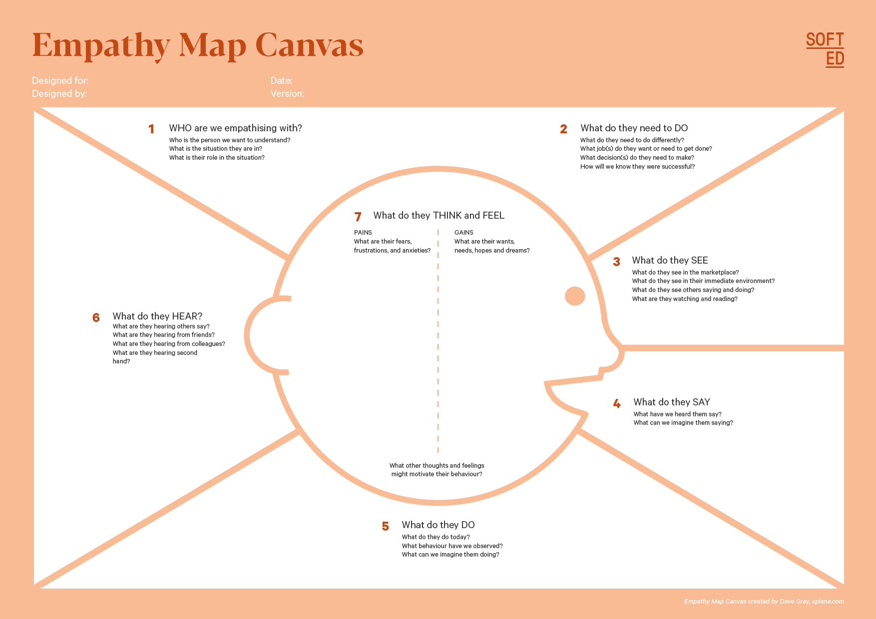

Your Answer:

Your Answer:

Who is your Customer Segment:

Idea/Innovation Title:

Designed By:

Date of Submission:

Your Answer:

Your Answer:

Your Answer:

Your Answer:

Your Answer:

Your Answer:

Your Answer:

1. **Empathy Map**
2. **Who is your Customer?**
   * **Name: Riya Sharma**
   * **Age: 35**
   * **Profession: Digital Marketing Manager**
   * **Uses the CMS during work hours, primarily on a desktop and occasionally on a tablet.**
   * **Needs support for multiple user roles to streamline teamwork and content approval.**
3. **Who are we empathizing with?**

**We are empathizing with Riya Sharma, a 35-year-old Digital Marketing Manager responsible for managing and distributing digital content.**

1. **What do they need to DO?**

**Riya needs to easily create, edit, and format various types of digital content (articles, blog posts, etc.).**

1. **What do they SEE?**

**Riya interacts with a modern office space, a user-friendly CMS interface, collaboration tools like Slack, industry materials for inspiration, and both desktop and tablet devices for flexibility.**

1. **What do they SAY?**

**Riya often shares insights like, “I need tools that simplify my workflow,” and posts on social media about the importance of effective content management, stating, “Collaboration is key to successful campaigns!”.**

1. **What do they DO?**

**Riya creates and schedules content, collaborates with her team using digital tools, analyzes content performance metrics, attends meetings to discuss strategies, and stays updated on industry trends.**

1. **What do they HEAR?**

**Riya hears feedback from colleagues about content performance, industry news and trends from marketing podcasts, insights from webinars, and advice from industry leaders on effective content strategies.**

1. **What do they THINK and FEEL?**

**Riya feels overwhelmed by tight deadlines and the pressure to deliver high-quality content, yet motivated by her passion for creativity and the impact of effective marketing. She worries about keeping up with industry trends and ensuring her team collaborates efficiently.**

1. **Pains and Gains**

**Riya faces tight deadlines, ineffective collaboration tools, and consistency challenges. She desires streamlined content management processes, improved team collaboration, and insights to enhance content performance.**

**8. Persona of Stakeholders**

**Stakeholder Name: Riya Sharma**

**Demographics:**

* **Age: 35**
* **Gender: Female**
* **Income: $75,000 annually**
* **Location: Urban area, working in a corporate environment**

**Goals:  
Riya aims to efficiently manage and distribute digital content to enhance brand visibility and engagement.**

**Challenges:  
She faces obstacles such as tight deadlines, ineffective collaboration tools, and the need for consistent, high-quality content.**

**Aspiration:  
Riya aspires to lead innovative marketing campaigns that significantly impact her company’s growth and establish herself as a thought leader in digital marketing.**

**Needs:  
Essential requirements include user-friendly content management tools, effective collaboration features, and analytics for performance tracking.**

**Pain Points:  
Riya experiences frustrations with managing multiple projects simultaneously, ensuring team alignment, and keeping up with industry trends.**

**Storytelling:  
Riya navigates her daily routine balancing multiple marketing projects while feeling the pressure of tight deadlines. She often struggles with outdated tools that hinder her team’s collaboration and productivity. By implementing a modern content management system, Riya can streamline her processes, enhance team communication, and ultimately achieve her goal of delivering impactful marketing campaigns that elevate her brand’s presence in the digital landscape.**

**10. Look for Common Themes, Behaviors, Needs, and Pain Points among the Users**

Analyse the data from your affinity diagram to uncover recurring patterns among your users, helping you better understand their expectations and challenges.

**Common Themes:**

* **Efficiency in Workflow: Users consistently express the need for tools that streamline content management and reduce administrative burdens.**
* **Collaboration and Communication: There is a recurring emphasis on the importance of effective teamwork and clear communication among team members.**

**Common Behaviors:**

* **Multitasking: Users frequently juggle multiple projects simultaneously, often switching between different tools and platforms.**
* **Seeking Feedback: Users actively seek input from team members and stakeholders to improve content quality and alignment with marketing goals.**

**Common Needs:**

* **User-Friendly Tools: Many users desire intuitive interfaces that simplify content creation, editing, and management.**
* **Analytics and Insights: Users require access to performance metrics and analytics to inform their strategies and enhance decision-making.**

**Common Pain Points:**

* **Time Constraints: Users often feel overwhelmed by tight deadlines, leading to stress and potential compromises in content quality.**
* **Ineffective Tools: Frustrations arise from using outdated or cumbersome collaboration tools that hinder productivity and team alignment.**

**12. Define Needs and Insights of Your Users**

**User Needs:**

1. **Functional Needs:**
   * **A user-friendly content management system that simplifies content creation, editing, and scheduling.**
   * **Effective collaboration tools that allow seamless communication and project management among team members.**
   * **Access to analytics and performance metrics to inform content strategy and decisions.**
2. **Emotional Needs:**
   * **A sense of control and confidence in managing multiple projects effectively.**
   * **Reduced stress from meeting tight deadlines through streamlined processes and efficient tools.**
3. **Societal Needs:**
   * **The ability to contribute to team success and recognition within the organization for successful marketing campaigns.**

**User Insights:**

* **Users like Riya often juggle multiple responsibilities, leading to a constant need for efficiency and time management in their workflows.**
* **Collaboration and communication are critical; users rely heavily on feedback and input from team members to ensure content quality and alignment with goals.**
* **Frustrations arise from inadequate tools, which often lead to inefficiencies, causing stress and impacting content quality.**
* **Users are motivated by the desire to produce impactful marketing campaigns and gain recognition, which drives their need for effective solutions that enhance their performance.**

**13. POV Statements**

**POV Statements:**

| **POV Statements** | **Role-based or Situation-Based** | **Benefit, Way to Benefit, Job TBD, Need (more/less)** | **PoV Questions** |
| --- | --- | --- | --- |

|  |  |  |  |
| --- | --- | --- | --- |
| Riya needs a way to streamline content creation processes because it helps her manage multiple projects efficiently. | Situation | Way to Benefit | What can we design that simplifies content creation for marketing managers like Riya? |

|  |  |  |  |
| --- | --- | --- | --- |
| Riya needs effective collaboration tools because team alignment is crucial for successful content delivery. | Situation | Way to Benefit | What can we create to enhance collaboration and communication within marketing teams? |

|  |  |  |  |
| --- | --- | --- | --- |
| Riya needs access to real-time analytics because it allows her to make informed decisions quickly. | Situation | Way to Benefit | What can we implement that provides immediate insights into content performance for users? |

|  |  |  |  |
| --- | --- | --- | --- |
| Riya needs a user-friendly CMS interface because it reduces her stress and boosts her productivity. | Situation | Way to Benefit | What can we develop that ensures an intuitive and easy-to-navigate content management system? |

|  |  |  |  |
| --- | --- | --- | --- |
| Riya needs to receive timely feedback from her team because it improves content quality and alignment with goals. | Situation | Way to Benefit | What can we design to facilitate quick and effective feedback loops among team members? |

|  |  |  |  |
| --- | --- | --- | --- |
| Riya needs to manage deadlines efficiently because tight timelines often lead to compromised content quality. | Situation | Way to Benefit | What can we create that helps users prioritize and manage deadlines without sacrificing quality? |

|  |  |  |  |
| --- | --- | --- | --- |
| Riya needs to stay updated on industry trends because it drives her content strategy and innovation. | Situation | Way to Benefit | What can we develop that aggregates and presents relevant industry news and trends for marketing professionals? |

|  |  |  |  |
| --- | --- | --- | --- |
| Riya needs to ensure content consistency across platforms because it strengthens brand identity and recognition. | Situation | Way to Benefit | What can we implement to help users maintain consistent messaging and branding in their content? |

|  |  |  |  |
| --- | --- | --- | --- |
| Riya needs efficient project management features because juggling multiple campaigns can be overwhelming. | Situation | Way to Benefit | What can we design that integrates project management capabilities within a content management system? |

|  |  |  |  |
| --- | --- | --- | --- |
| Riya needs to collaborate with remote team members effectively because a distributed workforce is becoming more common. | Situation | Way to Benefit | What can we create to enhance collaboration and communication tools for remote marketing teams? |

**14. Develop POV/How Might We (HMW) Questions to Transform Insights/Needs into Opportunities for Design**

| **User Need/Insight** | **"How Might We" Question** |
| --- | --- |
|  |  |

|  |  |
| --- | --- |
| Riya needs a way to streamline content creation processes because it helps her manage multiple projects efficiently. | How might we simplify the content creation workflow to enhance efficiency for marketing managers? |

|  |  |
| --- | --- |
| Riya needs effective collaboration tools because team alignment is crucial for successful content delivery. | How might we design collaboration features that foster seamless communication and alignment among team members? |

|  |  |
| --- | --- |
| Riya needs access to real-time analytics because it allows her to make informed decisions quickly. | How might we provide real-time analytics in a user-friendly format to support quick decision-making? |

|  |  |
| --- | --- |
| Riya needs to manage deadlines efficiently because tight timelines often lead to compromised content quality. | How might we create a deadline management tool that helps users prioritize tasks without sacrificing quality? |

|  |  |
| --- | --- |
| Riya needs to ensure content consistency across platforms because it strengthens brand identity and recognition. | How might we implement features that help users maintain consistent messaging across all content platforms? |

**16. Crafting a Balanced and Actionable Design Challenge**

**Design Challenge:**  
*How might we develop an integrated content management system that streamlines content creation, enhances collaboration, and provides real-time analytics, enabling marketing professionals to improve efficiency and content quality by 30% within the next six months?*

**17. Validating the Problem Statement with Stakeholders for Alignment**

Ensure your problem statement accurately represents the needs and concerns of your

| **Stakeholder/User** | **Role** | **Feedback on Problem Statement** | **Suggestions for Improvement** |
| --- | --- | --- | --- |
| Riya Sharma | Marketing Manager | The problem resonates; content creation is often time-consuming and inefficient. | Emphasize the need for specific tools that address project management. |
| Team Lead | Content Strategy Lead | The issue is relevant; alignment between teams is a recurring challenge. | Include collaboration examples to illustrate the problem more clearly. |
| IT Specialist | System Administrator | I see the need for real-time analytics; it’s crucial for decision-making. | Suggest focusing on data visualization in the solution. |
| UX Designer | User Experience Expert | The problem statement is good but lacks detail on user interface needs. | Add a focus on intuitive design for ease of use in content management. |
| Project Manager | Project Coordinator | The challenge resonates; timelines are often missed, affecting overall strategy. | Highlight the importance of tracking deadlines in the problem statement. |
| Content Creator | Copywriter | I relate to this issue; content consistency is critical for branding. | Suggest defining specific consistency challenges faced across platforms. |
| Social Media Manager | Digital Marketing Lead | This problem resonates; coordination for campaigns often falls short. | Emphasize cross-platform coordination in the problem statement. |
| Data Analyst | Analytics Specialist | The analytics aspect is relevant; immediate insights can enhance performance. | Recommend specifying which metrics are most important to track. |
| Graphic Designer | Visual Content Creator | The need for efficient tools resonates; design and content often clash under tight deadlines. | Suggest incorporating features that facilitate better design-content integration. |
| Operations Manager | Business Operations Lead | The problem is significant; operational efficiency could improve with better tools. | Focus on how the solution will align with overall business operations. |

**18. Ideation**

**Ideation Process:**

| **Idea Number** | **Proposed Solution** | **Key Features/Benefits** | **Challenges/Concerns** |
| --- | --- | --- | --- |
| **Idea 1** | **An integrated dashboard for content creation and management** | **Centralizes all tasks; provides real-time updates; easy access to analytics.** | **Complexity of integration with existing tools; user training needed.** |
| **Idea 2** | **Collaborative editing tools for team members** | **Allows multiple users to work on content simultaneously; reduces feedback loops.** | **Potential for version control issues; requires reliable internet.** |
| **Idea 3** | **Automated content scheduling and publishing** | **Saves time by scheduling posts across platforms; increases consistency in posting.** | **Scheduling conflicts may arise; need for clear guidelines on content timing.** |
| **Idea 4** | **Real-time analytics dashboard with customizable metrics** | **Provides instant insights into content performance; helps in quick decision-making.** | **Requires constant updates and data accuracy; can overwhelm users with too much data.** |
| **Idea 5** | **Mobile-friendly interface for on-the-go content management** | **Enables users to manage content from anywhere; enhances productivity.** | **Potential performance issues on older devices; ensuring responsive design.** |

**18. Idea Evaluation**

| **Idea** | **Impact (10/100/1000 grams)** | **Feasibility (10/100/1000 grams)** | **Alignment (10/100/1000 grams)** | **Total Weight** |
| --- | --- | --- | --- | --- |
| Idea 1 | 1000 | 100 | 1000 | 2100 |
| Idea 2 | 1000 | 500 | 1000 | 2500 |
| Idea 3 | 100 | 1000 | 100 | 1200 |
| Idea 4 | 1000 | 100 | 1000 | 2100 |
| Idea 5 | 100 | 1000 | 100 | 1200 |

**Solution Concept Form**

1. **Problem Statement:**
   * **Users struggle with managing content across multiple platforms efficiently, leading to time wastage and miscommunication among teams.**
2. **Target Audience:**
   * **Marketing managers, content creators, and social media teams looking for a streamlined solution to enhance collaboration and productivity in content management.**
3. **Solution Overview:**
   * **A comprehensive content management system that integrates collaboration tools, analytics, and scheduling features into a single platform, enabling users to manage content seamlessly.**
4. **Key Features:**

| **Feature** | **Description** |
| --- | --- |
| **Feature 1** | **Real-time collaboration tools for simultaneous editing and feedback.** |
| **Feature 2** | **Automated scheduling to publish content across multiple platforms effortlessly.** |
| **Feature 3** | **Customizable analytics dashboard providing insights into content performance and user engagement.** |

1. **Benefits:**

| **Benefit** | **Description** |
| --- | --- |
| **Benefit 1** | **Increases team productivity by streamlining communication and reducing feedback cycles.** |
| **Benefit 2** | **Enhances decision-making with real-time data and analytics on content performance.** |
| **Benefit 3** | **Offers a unique blend of collaboration, scheduling, and analytics that sets it apart from other solutions.** |

1. **Unique Value Proposition (UVP):**
   * **This solution uniquely combines real-time collaboration, automated scheduling, and actionable analytics in one platform, making it an indispensable tool for teams striving for efficiency in content management.**
2. **Key Metrics:**

| **Metric** | **Measurement** |
| --- | --- |
| **Metric 1** | **User engagement rate with content analytics features.** |
| **Metric 2** | **Reduction in time spent on content creation and publishing processes.** |

1. **Feasibility Assessment:**
   * **The solution is achievable with existing technologies and resources. The development timeline is manageable, focusing on integrating existing tools and ensuring a user-friendly interface.**
2. **Next Steps:**
   * **Conduct user interviews to refine features, create wireframes for the interface, develop a prototype for testing, and gather feedback for iterative improvements.**